Meeting of the Planning Committee of Wadhurst Parish Council held at The Pavilion, Sparrows Green Recreation Ground, South View Road, Wadhurst, TN5 6TW at 09:30 hours on 23rd March 2024 for the transaction of business as set out below.
Attendees: Cllr Shairp (Chair), Cllr Smith, Cllr P Moore, Cllr C Moore, & Cllr Anderson
Minutes
Meeting started at 9.45am. It was proposed by Cllr Shairp, seconded by Cllr Anderson and unanimously agreed that Cllr C Moore take the minutes.
1. To receive apologies for absence. Cllr Gadd

2. To receive declarations of interest and updates to members’ register of interests.
None

3. To approve the minutes of the meeting held on 9th March 2024.
It was proposed by Cllr Shairp, seconded by Cllr Smith and unanimously agreed that the minutes be approved.

4. To discuss matters arising from the minutes of the meeting of 9th March 2024

(Action: Clerk to update members as to whether alternative contractors to ESCC have been identified, that can advise and specify Highways scheme proposals, such as village gateways/traffic calming schemes)
(Action: Clerk to update members on status of response from WDC, as to why 10 extra days have been added to the recent FOI request relating to Bewl. We note that two Bewl planning applications are being presented to WDC Planning Committee North (PCN) re Bewl this Thursday (28th March) and the delay has meant a very short timeframe to review the 60 response items received from the FOI)
5. Public forum – time limit 15 minute. No members of the public attended

6. Pre- application briefings. None.
7. Correspondence. None.
8. WDC Decisions:
8.1 Application No. WD/2023/2944/FR INSTALLATION OF GROUND MOUNTED SOLAR PANELS AND CONTROL KIOSK BUILDING (RETROSPECTIVE) WICKHURST FARMHOUSE, BARTLEY MILL ROAD, WADHURST, TN3 8BH – APPROVED. We note our request for a condition to restore the land ‘as is’ if the equipment is no longer required has been granted in condition 4.
8.2 Application No. WD/2023/2752/F DETACHED OAK FRAMED OUTBUILDING TO REPLACE EXISTING DETACHED GAMES ROOM OUTBUILDING. CHEVIOT, NEWBURY LANE, WADHURST, TN5 6HD – APPROVED.
8.3 Application No. WD/2023/2746/F DETACHED OAK FRAMED GARAGE WITH STORAGE/WORKSHOP ABOVE FOLLOWING DEMOLITION OF EXISTING DETACHED GARAGE. CHEVIOT, NEWBURY LANE, WADHURST, TN5 6HD – APPROVED
9. To consider new planning applications.
9.1 Application No. WD/2024/0466/F
Full Expiry date for comments: 1 April 2024
Location: KESTRELS, JONAS LANE, WADHURST, TN5 6UJ
Description: DOUBLE STOREY SIDE EXTENSION, ADDITION OF PITCHED ROOF DORMERS TO THE ROOF AND ALTERATIONS TO THE EXISTING HABITABLE LOFT SPACE
Link to documents on web: https://planning.wealden.gov.uk/plandisp.aspx?recno=164941
Objection (Unanimous)
Contrary to the planning application form, the property is highly visible from the public road (across a great distance) as it is situated in an elevated position on the corner of Jonas Lane and Bankside. The proposed balcony is overlooking and inappropriate in relation to both the building and its position. See images below taken from Google Maps. And any roof lights need to be Dark Skies compliant.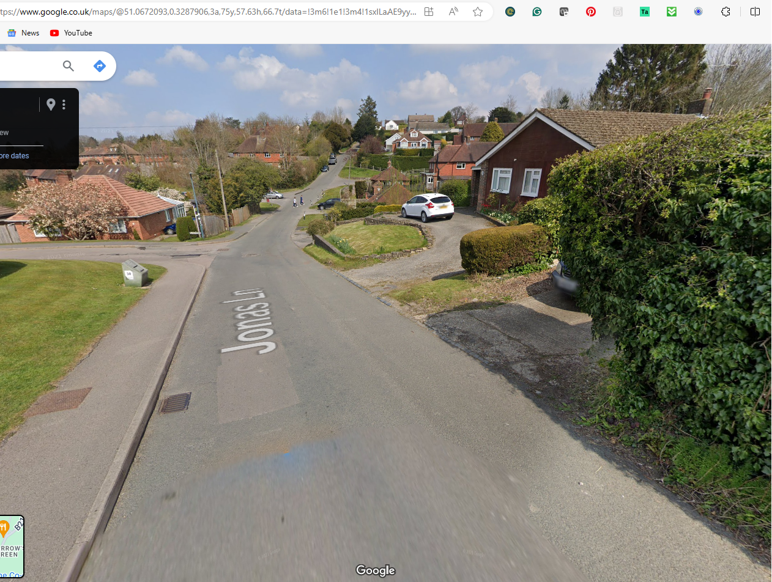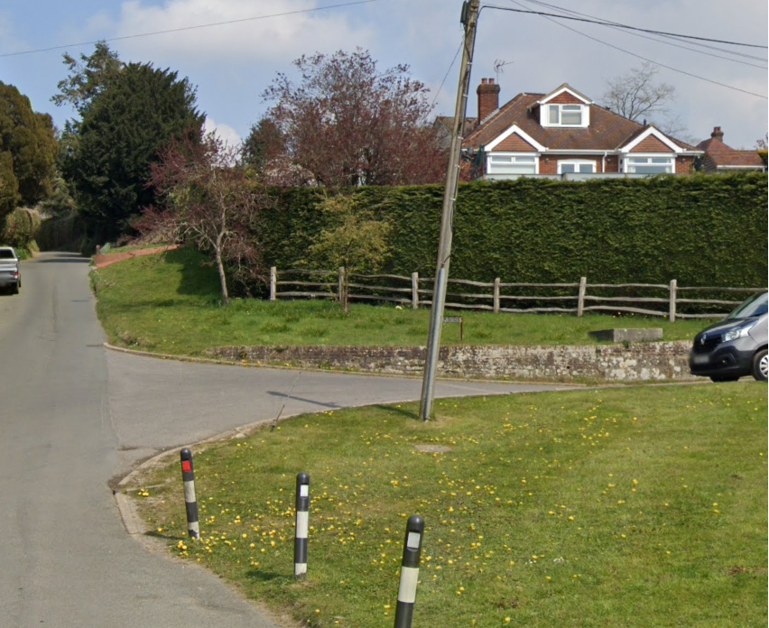
9.2 Application No. WD/2024/0401/F
Full Expiry date for comments: 29 March 2024
Location: WOODLANDS, MAYFIELD LANE, WADHURST, TN5 6JE
Description: PROPOSED DETACHED GARAGE/WORKSHOP WITH HOME OFFICE ABOVE, DRIVEWAY IMPROVEMENTS WITH NEW PARKING AREA, SWIMMING POOL AND POOL HOUSE.
Link to documents on web: https://planning.wealden.gov.uk/plandisp.aspx?recno=164857

Comment (Unanimous)
We note the neighbour concerns regarding proximity and overshadowing of the proposed garage as it will be on an elevated ridge, and request that the case officer carefully consider and investigate the impact on this neighbouring property. We draw the officer’s attention to some inconsistency (3 or 4 meters) in the description of the distance of the garage to the neighbouring property in the application documents. Should WDC be minded to approve the application, we request that a condition to ensure that the plot is not subdivided is included in order to;
- protect the character of the area, being a road of well-established large plots and
- prevent encroachment into the HWNL by further expansion due to the need for extension of the existing buildings or additional ancillary buildings if the garage was to be subdivided and used as a separate residence from the main dwellinghouse.

Whilst not the subject of this application, we note that much of the close board fencing fronting the property along Mayfield Lane has fallen down. Should the applicant be considering replacing it, we would respectfully request that the applicant considers the emerging Wadhurst Neighbourhood Plan’s Design Code, which advocates for the use of natural boundaries such as native hedging to protect Wadhurst’s rural feel and maintain wildlife corridors. Mayfield Lane is a fast road and the use of impermeable boundary treatments, particularly at this end of the lane, can result in animals, especially deer, becoming corralled and trapped in the road for longer than necessary as they try to find a way from one side to another; endangering themselves and road users.

9.3 Application No. WD/2024/0386/LB and WD/2024/0385/F
Expiry date for comments: 28 March 2024
Location: THE CROUCH HOUSE, CHURCHSETTLE LANE, WADHURST, TN5 6NH
Description: INTERNAL AND EXTERNAL ALTERATIONS TO A LISTED BUILDING, INCLUDING A NEW GLAZED PORCH AND NEW WINDOWS AND ROOFLIGHTS.
Link to documents on web: https://planning.wealden.gov.uk/plandisp.aspx?recno=164834

Objection (Majority)
Wadhurst Planning Committee note that a report from the Heritage Officer has not yet been received. We would ask that the heritage officer consider the rooflights, particularly the one proposed at the front of the building in view of the heritage status of the building. Should WDC be minded to approve the application, we request that conditions are imposed on the nature and specification of the rooflights in order to protect Wadhurst’s Dark Skies; as per WAD16 of the examined Wadhurst Neighbourhood Plan, which will go to referendum on the 2nd May 2024. Upward light spillage, such as from rooflights, is the most harmful to dark skies. Mitigation could include, for example, shielding with timing controls or glazing type. The very small settlement of Buttons is particularly rural and dark and it is important to residents that the predominantly unspoilt dark skies are kept that way.

10. Live planning applications
10.1 Application No. WD/2023/1895/MAJ
Campsite for up to 80 pitches and for the erection of a portacabin between the months of April and September.
See 10.3 below

10.2 Application No. WD/2021/0559/MAJ
Location: WEALD HALL RESIDENTIAL HOME, MAYFIELD LANE, WADHURST, TN5 6HX
Description: conversion of care home to form 8 no. flats together with the construction of 9 no. new dwellings and associated works
Approved at WDC PCN: RESOLVED that subject to a Section 106 Agreement to secure a commuted sum in lieu of affordable housing, Full Planning permission BE GRANTED.
Await further advice

10.3 Application No. WD/2023/2424/FR
Location: BEWL WATER, BEWLBRIDGE LANE, COUSLEY WOOD, WADHURST, TN3 8JH Description: THE
ERECTION OF FOUR YURTS (TWO RETROSPECTIVE AND TWO PROPOSED) AND RETENTION OF PORTACABIN
(TOILET AND WASH FACILITY) FOR YEAR-ROUND OCCUPATION.
We note that this application and that noted under 10.1 will go before WDC Planning Committee North (PCN) this Thursday (28th March). Members agreed unanimously to the following in relation to these two items:
ACTIONS
- two members of the WPC Planning Committee to attend the meeting to speak in opposition to the proposals (Cllr Shairp and Cllr P Moore)
- to commission a rebuttal statement from Ecologist Matt Phelps, further to the ‘Gull Report’ WPC commissioned from him last year. Up to £250 from the Planning Committee advice and report budget (Cllr C Moore)
- to write to the landlord, Southern Water, requesting that their tenant withdraw these planning applications until answers to WPC’s letter to Southern Water’s General Counsel are provided (Cllr C Moors)
- to notify residents of the meeting via social media (Cllr C Moore)
- to write a rebuttal statement to the Case Officer recommendations for approval. To be sent to WDC including WDC PCN councillors (Cllr Shairp drafting, all to input)
10.4 PLANNING & COMPENSATION ACT 1991, as amended-Certificate of Lawfulness for a PROPOSED USE. Ref No: WD/887/CMCL Description of site: Certificate of Lawfulness for the proposed use as a Household Waste Recycling Centre in accordance with extant planning permissions WD/1377/CC and WD/136/CM and their attached conditions involving the deposit of household waste at the site by members of the public and the importation of household waste by the operator. Faircrouch Depot, Household Waste Recycling, Faircrouch Lane, Wadhurst, East Sussex, TN5 6PT
Members discussed the practicalities of using the Black Cat survey equipment (Action: Cllr Shairp to find suitable times to meet with Cllr P Moore, Cllr Ramsden and Chair of WNP for set up/ hand over of Black Cat. To involve other members/residents as necessary. Working group to consider insurance requirements and if call for Speed Watch volunteers would be helpful.)

Clerk has written to Network Rail re bridge, weight limits, and to ESH re ‘no HGV’ signs, 30mph and traffic calming / width reductions. Awaiting response

Cllr C Moore has circulated data regarding previous use by Veolia including number of visits and tonnages. Cllr P Moore has written to transport consultant for advice. Awaiting response.
(Action: Cllr P Moore to identify potential contractors who can advise on traffic schemes)
(Action: Planning Committee to decide on timings for a meeting with residents following working party meeting.)
11. To monitor planning appeals received and make recommendations:
11.1 Ref: APP/C1435/W/23/3321704
LITTLE WINDMILL FARM, WINDMILL LANE, COUSLEY WOOD, WADHURST
Status: Awaiting result

11.2 Ref: APP/C1435/W/24/3336886
THE BOAT HOUSE BISTRO, BEWL WATER, BEWLBRIDGE LANE, COUSLEY WOOD, WADHURST, TN3 8JH
Status: Appeal lodged 15/01/24 but not yet validated
Unanimously agreed to make an FOI request for communications between the inspectorate and WDC in relation to this appeal. ACTION: Clerk to make the request.
ACTION carried forward: Cllr Shairp to write to the Secretary of State.
12. To consider any footpaths modification orders and make recommendations
12.1 Wildlife and Countryside Act 1981 - Section 53 Order Making Authority: East Sussex County Council Title of Order: Public Footpath Wadhurst 79a, 79b, 79c, 79d, 80, 81 & 82) Definitive Map Modification Order 2023
Members previously agreed to publicise. ACTION Cllr C Moore to do this on social media when the information to be shared is clarified.

13. Planning Control (& High Street Planning Enforcement)
14. To discuss Tree Preservation Orders Tapsells Wood, noted that officers have not decided yet on enforcement action for technical breach. ACTION: Clerk to request a timeframe for receiving a decision on Tapsells Lane wood due to concerns over wild bluebells and disruption during bird nesting season if pathworks are delayed. ACTION: Cllrs to communicate situation to residents.
15. Conservation areas
16. CIL
17. Policy/Correspondence/Consultations/Budget
18. Freedom of Information requests
18.1 FOIR to Wealden planning, sent 12/02/24: due in 20 working days, due back by 12/03/24
Address for correspondence is clerk@wadhurst-pc.gov.uk
Dear Planning Team
Under the Environmental Information Regulations, I would like to request the following information:
All correspondence, from January 2021 to date, between Ben Rainbow and any other WDC members or officers regarding the following applications or appeals:
· WD/2021/0638/F – Bewl Fishing Lodge application
· APP/C1435/W/22/3294192 – Bewl Fishing Lodge appeal
· WD/2021/2924/F – Bewl Bistro application
· APP/C1435/W/24/3336886 – Bewl Bistro appeal
Now received. ACTION Clerk to update members as per item 4, matters arising.

19. Neighbourhood Plan Update. Hardcopy documents now received from WDC and delivered by Cllr C Moore to Wadhurst Library where residents can view them. Referendum date confirmed as 2nd May 2024, documents on WDC website. ACTION Clerk to place on WPC website.
19.1 Discuss agenda for SG meeting with Wealden in Hailsham on 11 March at 3pm. Attendees updated the rest of the planning committee on the meeting.
20. Wealden Local Plan Update.
20.1 Site allocations
20.2 SHELAA assessments
20.3 Policies
20.4 Consultation process
21. Matter for noting or inclusion on future agenda.
22. Date of next meeting 6th April 2024
Meeting closed 11:35am

