Meeting of the Planning Committee of Wadhurst Parish Council held at The Pavilion, Sparrows Green Recreation Ground, South View Road, Wadhurst, TN5 6TW at 09:30 hours on 9th March 2024 for the transaction of business as set out below.
Attendees: Cllr Shairp (Chair), Cllr Smith, Cllr P Moore, Cllr C Moore, Cllr Gadd & Cllr Anderson
Minutes
It was proposed by Cllr Shairp, seconded by Cllr C Moore and unanimously agreed that Cllr Gadd take the minutes
1. To receive apologies for absence. None

2. To receive declarations of interest and updates to members’ register of interests.
Cllr Gadd declared an interest in WD/2024/0086/F

3. To approve the minutes of the meeting held on 10th February 2024.
It was proposed by Cllr C Moore, seconded by Cllr Shairp and unanimously agreed that the minutes be approved

4. To discuss matters arising from the minutes of the meeting of 10th February 2024

(Action: Clerk to advise as to whether alternative contractors to ESCC have been found)
(Action: Clerk to advise or chase for response, as to why 10 extra days have been added to the recent FOI request)

5. Public forum – time limit 15 minute. No members of the public attended

6. Pre- application briefings.
7. Correspondence
7.1 Weald Hall
7.2 Southern Water
8. WDC Decisions:
8.1 Application No. WD/2024/0123/F ALTERATIONS, DEMOLITION OF AN EXISTING REAR EXTENSION AND PROPOSED TWO STOREY SIDE AND REAR EXTENSIONS FIELDEN COTTAGE, THE DENS, WADHURST, TN5 6NJ – APPROVED
8.2 Application No. WD/2023/2830/F FLAT ROOF SINGLE STOREY EXTENSION TO THE REAR OF THE PROPERTY WITH INTERNAL ALTERATIONS TO CREATE AN OPEN PLAN LIVING, DINING AND KITCHEN SPACE. 2 TAPPINGTON COTTAGES, STATION HILL, WADHURST, TN5 6QA – APPROVED
8.3 Application No. WD/2023/1984/FA VARIATION OF CONDITION 14 OF WD/2021/3034/F DEMOLITION OF EXISTING GARAGE AND GARDEN STRUCTURES/OUTBUILDINGS INCLUDING SWIMMING POOL AND TENNIS COURT. ERECTION OF NEW PART SINGLE PART TWO STOREY DWELLING WITH DETACHED GARAGE, LANDSCAPING, POOL AND POOL PAVILION AND ASSOCIATED WORKS. PRIMMERS, PRIMMERS GREEN LANE, WADHURST, TN5 6DU – APPROVED
9. To consider new planning applications.
9.1 Application No. WD/2024/0086/F
Extension date requested for comments: 12th March 2024
Location: MOSTYN HOUSE, 15 MAYFIELD PARK, WADHURST, TN5 6DH
Description: PROPOSED NEW VEHICULAR ACCESS TO MAYFIELD LANE (B2100), TOGETHER WITH TIMBER GATES, POSTS AND FENCING AND PARKING/TURNING AREA FOR TWO CARS Link to documents on web: https://planning.wealden.gov.uk/plandisp.aspx?recno=164477
(Note: Cllr Gadd was not party to discussions and did not vote, due to interest)
Object
The proposal cuts into a rural verge and represents an encroachment on to the AONB. This would be urbanising and is contrary to High Weald AONB policy. The High Weald Housing Design Guide (page 18, para 3) states that:
“Soft edges to streets, such as banks, verges or swales are typical of the High Weald and have both visual and ecological value.”
Road safety: This area of Mayfield Lane is already an area of concern for students crossing the road to get to the school nearby. The proposed entrance is onto a main road onto a historic routeway. WPC has doubts about the visibility splays that apply to the entrance. Specifically, the driveway is close to a major road sign, that would obscure the view when a driver exits this site.
There was a loss of a garage in a recent development on this site. WPC wonders why this was not considered when approved by WDC? There is also a loss of the tree line along Mayfield Lane.
If WDC is minded to approve this application, WPC strongly requests that the Council impose conditions:
- that requires 'no additional housing be added to this site in the future'
- that would suggest a gravel (i.e. a permeable) drive, rather than tarmac.
- that the applicants achieve bio-diversity net gain, in an overall urbanising proposal, by replacing the current close board fence with a native hedgerow.
Objection (Unanimous)
9.2 Application No. WD/2024/0223/FR
Full Expiry date for comments: 22nd March 2024
Location: LAND AT BROADFIELD HOUSE, BEST BEECH HILL, WADHURST, TN5 6JH Description: PART RETROSPECTIVE APPLICATION FOR THE ERECTION AND OPERATION OF 68 GROUND MOUNTED SOLAR PV PANELS FOR DOMESTIC USE. Link to documents on web: https://planning.wealden.gov.uk/plandisp.aspx?recno=164638
Object

To prevent encroachment into the AONB and ensure support from residents, a strict condition must be added to ensure that the land reverts to its previous agricultural status, if solar panels are removed.

WPC is strongly supportive of the benefit to the environment by the use of solar panels, but must ensure that no precedents are set by such sites becoming detrimental to the environment by allowing them to become brownfield sites, once solar panels are removed.

For the previous application, WPC recommended that a condition be added to the WDC decision. This was done with the following condition added by WDC in its decision:
Within 6 months of the photovoltaic array hereby permitted ceasing to be required and used for the generation of electricity, it shall be removed from the site and the land restored to its former condition, or to a condition that may otherwise be first agreed in writing by the Local Planning Authority.

WPC supports the placing of this condition, but is concerned that the final clause offers an easy ‘get-out’ for opportunistic developers, who want to ‘create’ a brownfield so that they can develop.

Therefore, subject to the removal of the final sentence of WDC’s condition (‘or to a condition that may otherwise be first agreed in writing by the Local Planning Authority’), we would be minded to not object to this application.

Object (Unanimous)
9.3 Application No. WD/2023/2561/F and WD/2023/2562/LB
Full Expiry date for comments: Expired
Location: CHITTINGHURST FARM, TIDEBROOK, WADHURST, TN5 6PQ
Additional remarks to previous objection

Wadhurst Planning Committee (WPC) note that a report from the Heritage Officer has not yet been received, assessing the impact on this Grade 1 listed farmstead. In addition, the WPC request that this application be referred to the High Weald Area of Outstanding Natural Beauty (HWAONB) unit as this submission affects a historic farmstead.
This site is representative of one of the key High Weald National Landscape characteristics; being an isolated farmstead arranged around a routeway (as described on page 31 of the High Weald AONB Management Plan). The suburbanisation and conversion of agricultural buildings to residential is a top issue for the HW (as described on page 32 of the High Weald AONB Management Plan).

We note the adjoining neighbour objection (Robert Agnew, Chittinghurst, 12 November 2023) and wish WDC to note our strong endorsement of the points made.

In addition we note that the footpath consultation response has not yet been received but wish to remind WDC that a public footpath runs directly through the centre of this farmstead within feet of the proposal and therefore, is highly visible to the general public and impacts on this historic routeway.

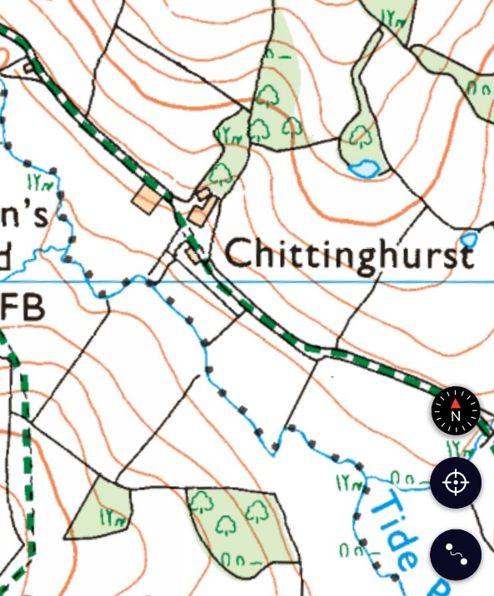
Figure 1 – Ordnance survey map showing public footpath running between the buildings
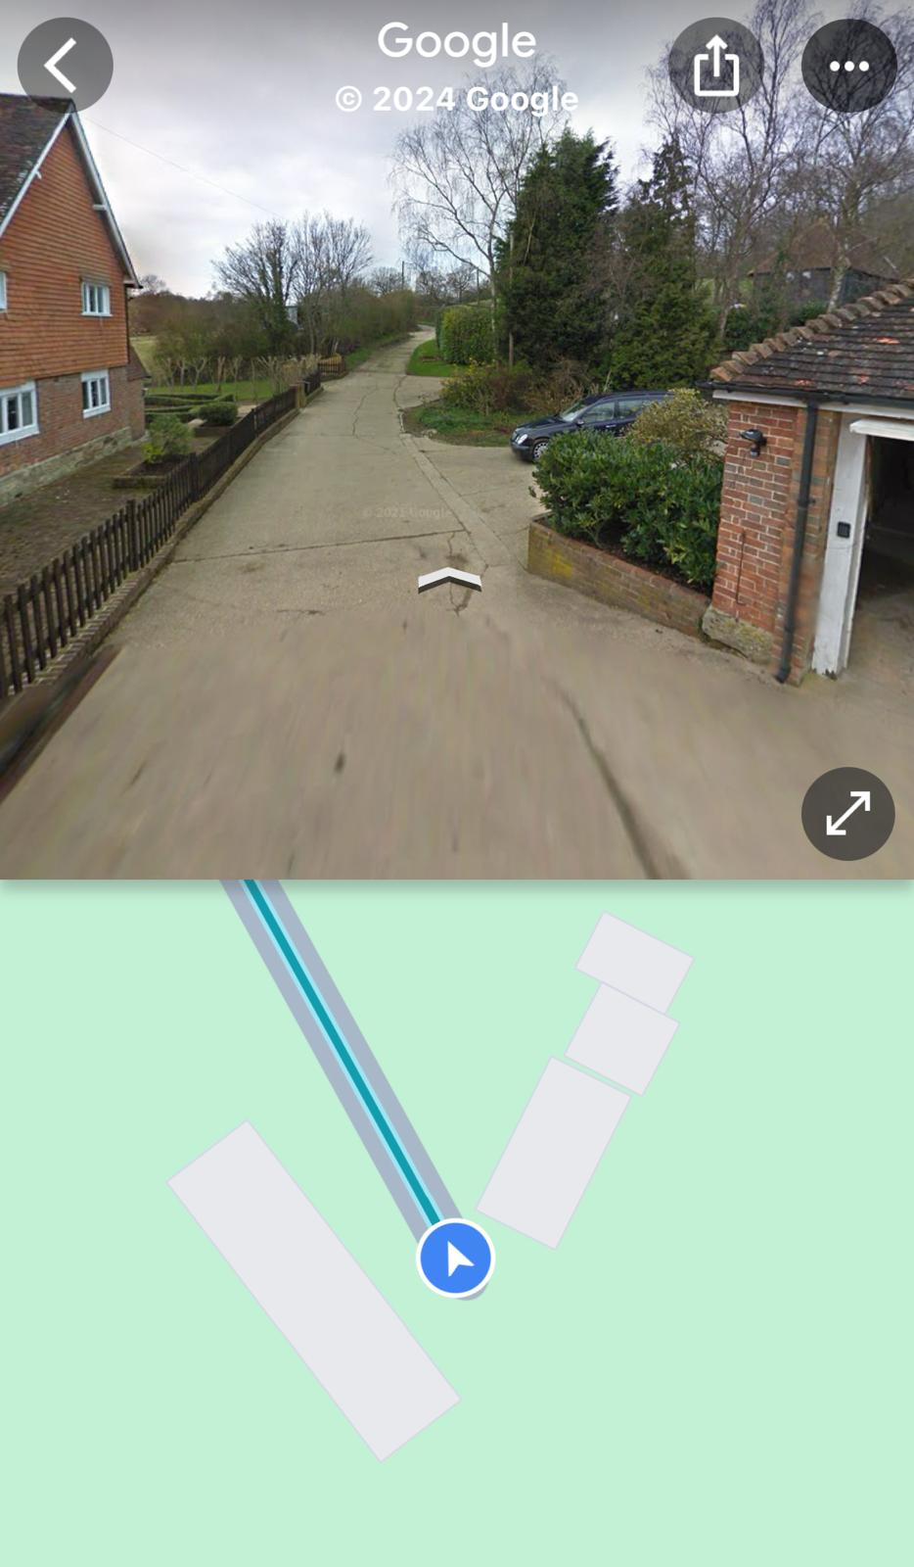
Figure 2 – public footpath running through the historic farmstead
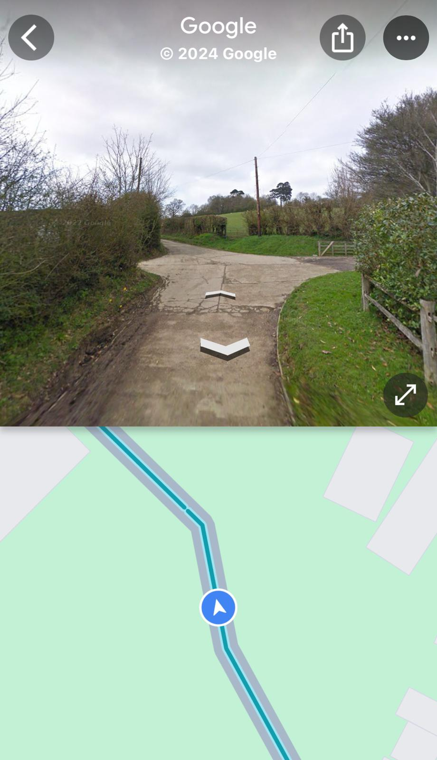
Figure 3 – the existing low level agricultural buildings merge into their surroundings. The proposed building would dominate the lane and neighbouring buildings – especially by overlooking Chittinghurst.

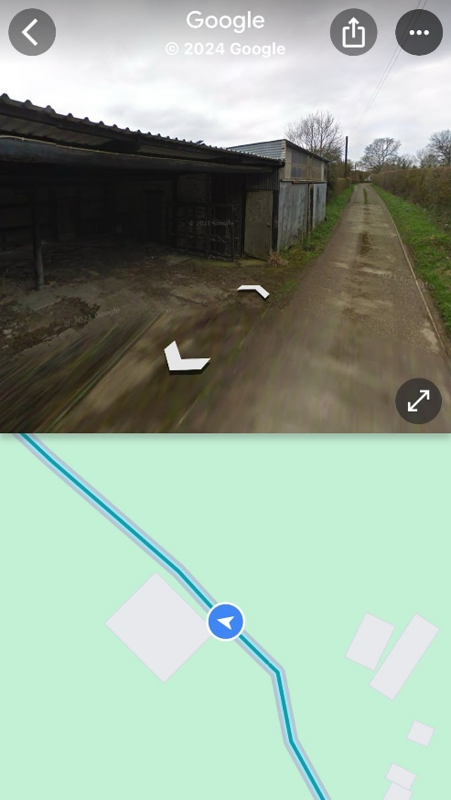
Figure 4 – application site is directly onto the public footpath. Although not attractive, these agricultural buildings are in keeping with the rural location and character of a farmstead.
In addition to the points made by the adjoining neighbour in relation to design, the proposed design conflicts with the emerging Wadhurst Neighbourhood Plan design code and dark skies policies.

We also note that “based on the information supplied” the ESCC Archaeological Officer has “no archaeological recommendations to make” in his letter of 22 November. We request that this decision is reviewed, or clarity is given on the information supplied to him as the basis for his decision in view of the High Weald AONB Management Plan guidance that requires “an archaeological assessment for the development affecting historic farmsteads” and the information provided by the adjoining neighbour (Robert Agnew, Chittinghurst, 12 and 19 November 2023).

Whilst the farmstead buildings may now be in separate ownership, they read as a farmstead group and as such the impact of this proposal is greater than if this was an isolated edifice.
In conclusion, this proposal is out of keeping, out of scale, fails against a key objective of the High Weald AONB Management Plan to prevent the fragmentation and urbanisation of historic farmstead and will have a negative impact on the beautiful and very visible rural Grade 1 buildings.
10. Live planning applications
10.1 Application No. WD/2023/1895/MAJ
Campsite for up to 80 pitches and for the erection of a portacabin between the months of April and September.
Await further detail
10.2 Application No. WD/2021/0559/MAJ
Location: WEALD HALL RESIDENTIAL HOME, MAYFIELD LANE, WADHURST, TN5 6HX
Description: conversion of care home to form 8 no. flats together with the construction of 9 no. new dwellings and associated works
Approved at WDC PCN: RESOLVED that subject to a Section 106 Agreement to secure a commuted sum in lieu of affordable housing, Full Planning permission BE GRANTED.
Await further advice
10.3 Application No. WD/2023/2424/FR
Location: BEWL WATER, BEWLBRIDGE LANE, COUSLEY WOOD, WADHURST, TN3 8JH Description: THE
ERECTION OF FOUR YURTS (TWO RETROSPECTIVE AND TWO PROPOSED) AND RETENTION OF PORTACABIN
(TOILET AND WASH FACILITY) FOR YEAR-ROUND OCCUPATION.
No update to date
10.4 PLANNING & COMPENSATION ACT 1991, as amended-Certificate of Lawfulness for a PROPOSED USE. Ref No: WD/887/CMCL Description of site: Certificate of Lawfulness for the proposed use as a Household Waste Recycling Centre in accordance with extant planning permissions WD/1377/CC and WD/136/CM and their attached conditions involving the deposit of household waste at the site by members of the public and the importation of household waste by the operator. Faircrouch Depot, Household Waste Recycling, Faircrouch Lane, Wadhurst, East Sussex, TN5 6PT
Email sent to residents on 6th March to outline what WPC has been doing.
(Action: Cllr Shairp to address Black Cat survey to gather figures prior to change.)

(Action: Planning Committee to decide on timings for a meeting with residents)

(Action: Cllr P Moore to investigate Civil Contractors available to assess, weight limits, ‘no HGV’ signs, 30mph and traffic calming / width reductions.)

(Action: Clerk/Cllr C Moore to investigate data regarding previous use by Veolia i.e. weights and direction of travel.)

(Action: Cllr Shairp to contact transport consultant for advice.)

It was proposed by Cllr P Moore, seconded by Cllr Anderson and agreed by majority that the Planning Committee would be looking to spend up to £4k when deciding on advice options.
11. To monitor planning appeals received and make recommendations:
11.1 Ref: APP/C1435/W/23/3321704
LITTLE WINDMILL FARM, WINDMILL LANE, COUSLEY WOOD, WADHURST
Status: Awaiting result
11.2 Ref: APP/C1435/W/24/3336886
THE BOAT HOUSE BISTRO, BEWL WATER, BEWLBRIDGE LANE, COUSLEY WOOD, WADHURST, TN3 8JH
Status: Appeal lodged 15/01/24 but not yet validated
It was proposed by Cllr Shairp, seconded by Cllr Gadd and unanimously agreed that a decision regarding the next steps regarding WPC’s efforts to request that the appeal be heard by an Inquiry rather than by Written Representation would be carried out via email, following a meeting with Wealden on 11th March
12. To consider any footpaths modification orders and make recommendations
12.1 Wildlife and Countryside Act 1981 - Section 53 Order Making Authority: East Sussex County Council Title of Order: Public Footpath Wadhurst 79a, 79b, 79c, 79d, 80, 81 & 82) Definitive Map Modification Order 2023
13. Planning Control (& High Street Planning Enforcement)
14. To discuss Tree Preservation Orders
15. Conservation areas
16. CIL
17. Policy/Correspondence/Consultations/Budget
18. Freedom of Information requests
18.1 FOIR to Wealden planning, sent 12/02/24: due in 20 working days, due back by 12/03/24
Address for correspondence is clerk@wadhurst-pc.gov.uk
Dear Planning Team
Under the Environmental Information Regulations, I would like to request the following information:
All correspondence, from January 2021 to date, between Ben Rainbow and any other WDC members or officers regarding the following applications or appeals:
· WD/2021/0638/F – Bewl Fishing Lodge application
· APP/C1435/W/22/3294192 – Bewl Fishing Lodge appeal
· WD/2021/2924/F – Bewl Bistro application
· APP/C1435/W/24/3336886 – Bewl Bistro appeal
Date noted
19. Neighbourhood Plan Update.
19.1 Discuss agenda for SG meeting with Wealden in Hailsham on 11 March at 3pm
20. Wealden Local Plan Update.
20.1 Site allocations
20.2 SHELAA assessments
20.3 Policies
20.4 Consultation process
21. Matter for noting or inclusion on future agenda.
22. Date of next meeting 23rd March 2024
Meeting closed 11:55am

