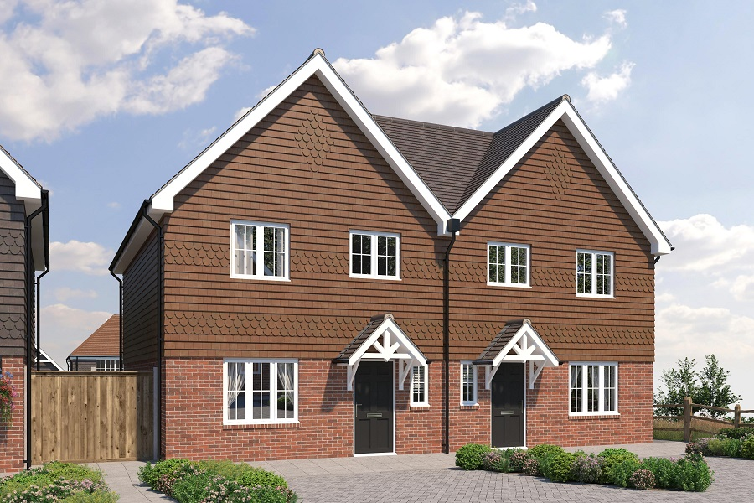

£125,000 (25% OF £500,000 )
PART SHARE’S AVAILABLE, THE GROVE WADHURST

PART SHARE - MINIMUM SHARE 25% Eastbourne Property Shop is delighted to offer to the market two part share properties in the popular village of Wadhurst. Built by Greymoor homes, accommodation comprises of lounge, modern fitted kitchen/diner with built-in appliances, and downstairs w,c,. Upstairs the property benefits from three good size bedrooms and a modern fitted family bathroom. Further benefits include front and rear gardens and off-road parking.
£125,000 for 25 % share
( CGI courtesy of Greymoor Homes )
Call today for further information 01323 764122
www.eastbournepropertyshop.co.uk
