Wealden District Council
Statement of Community
Involvement
Consultation Draft

May 2020

How to Contact Us

Planning Policy
Wealden District Council
Council Offices, Vicarage Lane, Hailsham, East Sussex BN27 2AX

Telephone 01892 602008
E-mail: planningpolicy@wealden.gov.uk
Website: www.wealden.gov.uk

If you, or somebody you know, would like the information
contained in this document in large print, Braille, audio tape/CD or in another language please contact Wealden District Council
on 01323 443322 or info@wealden.gov.uk

Wealden Local Plan
Draft Statement of Community Involvement May 2020

1

Introduction 3

2 Local Planning Documents 5
3 Who the Council will involve in plan making 9
4 Producing a Local Plan 11
5 Supplementary Planning Documents 15
6 Community Infrastructure Levy 19
7 Neighbourhood Plans 23
8 Development Management and community involvement 27
9 How we use your data 33
10 Glossary 35
Appendices
Appendix A 37
Appendix B 39
Appendix C 41
Contents

Wealden Local Plan
Draft Statement of Community Involvement May 2020
Contents

Wealden Local Plan
Draft Statement of Community Involvement May 2020

1 Introduction
1.1 The planning system is an important part of our lives and affects us all in some way; from the homes and streets we live in, the places that we work, the location and types of shops that we shop in, as well as the outdoor spaces and natural environment that we spend time relaxing in.
1.2 How Wealden District develops in the future will be led by the planning system. It is therefore important that the local community and stakeholders know how they can take part in the planning process and participate in planning decisions.
1.3 Understanding the issues, opportunities, challenges and options is an important part in the plan making process and engagement and consultation with relevant partners and communities is essential to this.
What is a Statement of Community Involvement?
1.4 A Statement of Community Involvement (SCI)⁽¹⁾ is a document that sets out what consultation will take place when we are developing and reviewing our planning documents and determining planning applications. It also provides information as to how the Council will work with our partners and communities (‘qualifying bodies’) to facilitate proposals for neighbourhood plans or orders.
How does the planning system work?
1.5 There are two main parts to the planning system which are mirrored by the services provided by Wealden District Council:
Planning Policy is concerned with the preparation of local development documents and policies that are used to guide development in Wealden District. These documents provide information on how the district will change during the plan making period, which must be for at least 15 years. The documents must conform to relevant
government guidance and policy and there are specific statutory procedures that must be followed during the preparation of the documents.
Development Management is responsible for processing and determining planning
applications for new development, changes of use for development and also
determines applications in relation to listed buildings, advertisements and works to
certain trees where they are covered by a Tree Preservation Order. The Development
Management team also provides pre-application planning advice and investigates
and where appropriate takes action where breaches of planning control have taken
place.
1.6 In addition to the above, Wealden District Council also provides advice and
assistance to Town and Parish Councils who are developing Neighbourhood Plans for
their areas.

1 The production of an SCI is a legislative requirement by reference to Section 18 of the Planning and Compulsory Purchase
Act 2004 (as amended)

3

1 Introduction

Wealden Local Plan
Draft Statement of Community Involvement May 2020

Consultation on Wealden District Council’s Statement of Community Involvement
1.7 There is no formal requirement for local planning authorities to consult when
reviewing or updating their SCIs. However, we consider that community involvement from
the outset in the local planning system is important and we would like to provide an
opportunity for our local communities, businesses and other relevant parties to comment
on the process and methods that we intend to use to engage with you in the planning
services we provide.
1.8 Wealden District Council adopted its previous SCI in 2015, however since this time there have been a number of changes to planning legislation and guidance as well as technological advances, which provides opportunities to change the way that we engage with our local communities in the local planning system.
1.9 This revised version of the SCI accounts for these changes, which include:
A requirement for local authorities to set out their policies for giving advice or
assistance on making and modifying neighbourhood development plans (NDP), or making neighbourhood development orders (NDO) and Community Right to Build Orders to grant planning permission;
A requirement for local authorities to review their SCI every five years; and
There is government encouragement to use social media tools and other platforms to communicate with communities.
1.10 We are also taking this opportunity to update the SCI to account for the current stage we are at in the plan making process.
1.11 The Council is seeking your views on the content of this draft document and the consultation on this SCI will run for a period of six weeks. The consultation will take place between 4th May 2020 and midnight on 15th June 2020.
1.12 Should you have any questions about this SCI then please contact the Planning
Policy Team via email at planningpolicy@wealden.gov.uk or call 01892 602008.
1.13 You can also contact us at Wealden District Council offices, Vicarage Lane,
Hailsham, BN27 2AX and on the Councils website at www.wealden.gov.uk.

4
1 Introduction

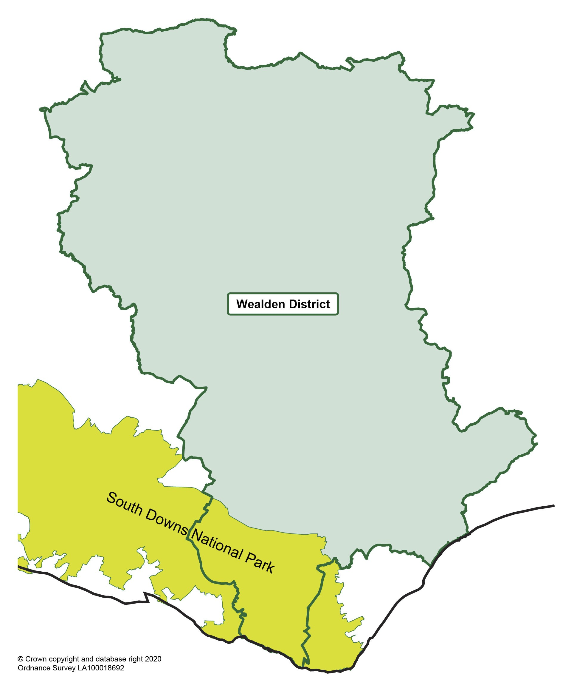

Wealden Local Plan
Draft Statement of Community Involvement May 2020

2 Local Planning Documents
2.1 Wealden District Council is responsible for plan making and preparing local planning documents in Wealden District, apart from the area of the district located within the South Downs National Park, as shown in figure 1 below. The South Downs National Park Authority is the planning authority for this area and has its own SCI for its area.
Figure 1: Area of Wealden District located within the South Downs National Park

5
2 Local Planning Documents

Wealden Local Plan
Draft Statement of Community Involvement May 2020

2.2 There are two main types of planning documents including ‘Development Plan Documents’ and ‘Supplementary Planning Documents’.
Development Plan Documents - Local Plans
2.3 Development Plan Documents (DPDs) is the collective term used to describe Local
Plans. Local Plans, when prepared, comprise the development plan for the area, together
with any ‘made’ Neighbourhood Plans. Planning applications should be determined in
accordance with the development plan unless material considerations indicate otherwise.
2.4 Local Plans, in general, set out policies for a particular geographical area for the
next 15 years. They contain policies to guide development and they often include site
allocations where development will take place and identify areas that are to be protected
from development.
2.5 A Local Plan is subject to a number of assessments including a Sustainability
Assessment, which assesses the environmental, social and economic impacts of a plan
and an Equalities Impact Assessment, which ensures that the needs of all people are
taken into account. A Local Plan is also subject to a Habitats Regulations Assessment,
which considers whether a plan or its policies would impact on a European site designated
for its biodiversity.
2.6 As required by national planning policy and legislation, Local Plans must be produced
through public consultation and engagement with the community. They must also be
considered at independent examination and obtain Council approval before they can be
adopted.
2.7 The following Local Plan’s currently comprise Wealden District Council’s development
plan (not including the area of Wealden District located within the South Downs National
Park):
Saved policies contained in the Wealden District Local Plan (1998); Wealden District Core Strategy Local Plan (February, 2013);
East Sussex, South Downs and Brighton & Hove Waste and Minerals Local Plan (February 2013);
Affordable Housing Delivery Local Plan (May, 2016);
East Sussex, South Downs and Brighton & Hove Waste and Minerals Sites Plan (February 2017); and
Herstmonceux Neighbourhood Development Plan (July, 2019).
2.8 In addition to the above, legislation⁽²⁾ provides that a local planning authority must have regard to a post-examination draft neighbourhood development plan, so far as material to the application. At this time both Hailsham Neighbourhood Plan and Hellingly Neighbourhood Plan are at the post-examination stage. This will also apply to any other neighbourhood plans at the post-examination stage as they are progressed.

6

2 Section 70(2) of the Town and Country Planning Act 1990 (as amended)

2 Local Planning Documents

Wealden Local Plan
Draft Statement of Community Involvement May 2020

2.9 The Local Development Scheme (LDS) sets out the Council’s plan making timetable for the production of planning policy documents. At the time of writing, the Council is currently updating its LDS. Once agreed, this will be available on the Council’s website and is the starting point for the community and stakeholders to find out about emerging planning policy documents.
2.10 The Authority Monitoring Report (AMR) monitors the implementation of the LDS
and determines whether adopted planning policies are delivering their objectives. The
AMR is published at the end of December every year. If there has been unavoidable
slippage in the LDS timetable, the AMR will explain the reasons for delay and any
amendments to the LDS timetable for the implementation of planning policy documents.
2.11 The AMR can be accessed via the Council’s website at: Authority-Monitoring-Report

7
2 Local Planning Documents

Wealden Local Plan
Draft Statement of Community Involvement May 2020

8
2 Local Planning Documents

Wealden Local Plan
Draft Statement of Community Involvement May 2020

3 Who the Council will involve in plan making
Duty to Cooperate
3.1 The Localism Act 2011 places a duty on the Council to work and cooperate with other local planning authorities, the County Council and other prescribed bodies⁽³⁾ to address strategic planning issues that cross administrative boundaries.
3.2 As part of the duty to cooperate process, authorities are required, as set out in the
NPPF, to produce and maintain statements of common ground, which is a written record
of progress made by strategic policy-making authorities during the process of planning
for strategic cross-boundary matters. The purpose is to document where cooperation is
and is not happening through the plan-making process. The statements will provide
evidence that Local Plans are effective in relation to them being deliverable over the
specified plan period and are sound in that they have been based on effective joint working
on cross-boundary strategic matters.
3.3 The Council will meet its requirements under the duty to cooperate through regular engagement with its partners and will publish statements of common ground as they are prepared and finalised for publication.
Specific’ and ‘general’ consultation bodies
3.4 Legislation⁽⁴⁾ provides the minimum legal requirement for consultation on local plan documents. This includes:
Specific consultation bodies who must be consulted at formal consultation stages in local plan production. This includes statutory authorities such as neighbouring districts, government agencies and utility providers;
General consultation bodies include organisations and bodies who have an interest in the district. This can include interest and amenity groups, residents associations, property, trade and business associations, voluntary organisations and bodies that represent issues of race, ethnicity, gender, age, sexual orientation, disabilities and those with caring responsibilities⁽⁵⁾; and
Residents, businesses and landowners located in the local authority area.
3.5 Both ‘general’ and ‘specific’ consultees are provided in Appendix B.
3.6 It should be noted that not everyone will be contacted directly in respect of every planning document, as details of the consultation will be made available by a range of communication methods outlined in this document. The SCI provides a flexible, sensitive, proportionate and targeted approach to consultation across the entire local authority area by involving interested and affected parties. Council Members will be notified directly of consultation on every planning document produced by the Council⁽⁶⁾.

3 The full list of organisations and prescribed bodies are listed in Appendix A
4 Regulation 18, Town and Country Planning (Local Planning)(England) Regulations 2012
5 Regulation 2, Town and Country Planning (Local Planning) (England) Regulations 2012
6 This does not include Neighbourhood Plans where consultation is undertaken by Town or Parish Councils

9

3 Who the Council will involve in plan making

Wealden Local Plan
Draft Statement of Community Involvement May 2020

3.7 As an example, an SPD that relates to only part of the District would benefit from
targeted consultation in that area and not with parties that would be unaffected by the
plans.
3.8 Local authorities need to have regard to the Public Sector Equalities Duty, as referred
to in the Equalities Act 2010, in respect of engaging with people with ‘protective
characteristics’. The SCI follows the principles of the Councils Equality objectives, which
sets out the Council’s commitment to the provision of services for all the community and
to ensure that everyone has equal access to our services and information. We will ensure
that any public consultation events are held at accessible venues and we will make
reasonable adjustments to enable participation and involvement in consultations.
3.9 Following key consultation stages the Council will produce consultation summary
reports which will provide information on the key issues raised and will provide a response
to these prior to finalising a planning document. This summary will be available on the
Council’s website.

10
3 Who the Council will involve in plan making

Wealden Local Plan
Draft Statement of Community Involvement May 2020

4 Producing a Local Plan
4.1 The key stages of community involvement during the preparation of a local plan are identified in Figure 2 below:
Figure 2: Local Plan - Key stages of community involvement

1. Pre-production and informal consultation:
The Council will publicise on its website the timetable for plan-making; Notify and work with groups, organisations and relevant parties;
Collect evidence and information through various sources;
Confirm relevant environmental, economic and social objectives to inform the Sustainability
Appraisal;
Identify high level issues, opportunities, challenges and options;
Identify key strategic cross-boundary matters and develop high level spatial options; Consult for a minimum of six weeks;
Provide a summary of the responses made to the early engagement consultation.

2. Preparation of a Draft Local Plan;

Engage and consult on the draft plan (with those listed above) and provide a minimum period of six weeks for comments to be made;
Make certain supporting documents available as part of the consultation on the Council’s website including the Sustainability Appraisal;
Consider responses and provide a summary of the responses received; and Continue to collect and finalise evidence, as required.

3. Publication of Pre-Submission Local Plan

Publication of the Pre-Submission Local Plan on the Council’s website for a minimum of six weeks and request for representations to be made on the plan;
Publication of evidence base and supporting documents including the Sustainability Appraisal; Documents to be made available on the Council’s website; and
Prepare a report for the Planning Inspectorate setting out the main issues and a response summary.

11
4 Producing a Local Plan

Wealden Local Plan
Draft Statement of Community Involvement May 2020

4. Submission for Independent Examination

Local Plan, evidence base, supporting documents, statement of consultation and representations received submitted to the Secretary of State for Independent Examination;

12
Independent Inspector assesses the plan and supporting documentation submitted and undertakes the Examination in Public, of which, parties can engage at the examination, as relevant⁽⁷⁾; and
Inspector issues report following the conclusion of the examination.

5. Adoption of Local Plan

If the Local Plan is found sound, a Council decision is taken whether to formally adopt the Local Plan;
and
Produce post-adoption statement and monitor sustainability.

6. Monitoring and review

The ‘adopted’ plan is monitored on an annual basis, to ensure that the plan is being implemented and is achieving its aims; and
A review of the plan is undertaken, as necessary and at least every five years.

Consultation Methods
4.2 The following consultation methods will be used at the various stages in the Local
Plan process. The Council’s Local Plan webpages will be kept up-to-date as the Local
Plan progresses and evidence base documents will be up-loaded as they are completed.

7 Once the plan is submitted for examination, the Council will appoint a Programme Officer who is responsible for all communication
between the Inspector and all parties

4 Producing a Local Plan

Wealden Local Plan
Draft Statement of Community Involvement May 2020

Table 1: Local Plan Consultation Methods

Method of consultation | Development Plan preparation stage
 | Pre-production  and informal  consultation | Preparation  of a Draft  Local Plan | Publication  of  pre-Submission  Local Plan | Submission  for  Independent  Examination | Adoption  of Local  Plan
Statutory requirement
Written / email notification  to duty to cooperate  partners, general and  statutory consultees,  businesses and other  relevant parties including  relevant stakeholders,  individuals and  organisations who are  registered on the Council's  planning policy database. | Y | Y | Y | Y | Y
Make consultation  documents available for  inspection at the Council's  office and other key  locations across the district  such as libraries. | Y | Y | Y | Y | Y
Make consultation  documents, supporting  documents and information  available on the Council's  website. | Y | Y | Y | Y | Y
Potential additional methods subject to resources
Publicise on the Council's  website. | Y | Y | Y | Y | Y
Public consultation event(s)  held in accessible locations. | N | Y | N | N | N
Publicise on social media  including Facebook and  Twitter. | Y | Y | Y | Y | Y
Publicise on the Council's  My Alerts system. | Y | Y | Y | Y | Y
Leaflets / posters | N | Y | N | N | N
4.3 All consultations will be published on the Council’s consultation portal and responses to consultations can be submitted via this portal. We will also provide an opportunity to download a questionnaire or response form from our website.
13
4 Producing a Local Plan

Wealden Local Plan
Draft Statement of Community Involvement May 2020

4.4 Hard copies of documents will be made available at specific deposit points (as relevant) including the Council offices at Hailsham. Also hard copies of documents can be made available on request. Please note that should hard copies of documents be requested then there will be a charge for these commensurate with the cost of producing the document. The cost of hard copies of documents will be provided on our website or communicated to you should we receive a telephone or email request.
4.5 At this time, plan-making has been affected by Covid-19 and the Government is encouraging local planning authorities to continue, as much as possible, to work proactively with communities and other stakeholders to progress plans, even if some adjustment to timetables are necessary.
4.6 For certain consultations, the Council would ordinarily provide planning policy documents for inspection at deposit points such as libraries, at certain Town or Parish Council offices and the District Council office. This will not be possible during times where social distancing is required. The Council will keep under review its engagement processes to proactively work with communities and stakeholders. If you are unable to view a document on the Council’s website, then please, in the first instance, contact the planning policy team for advice and we will discuss options with you.
Local Plan Database
4.7 At the time of writing, Wealden District Council is producing a new Local Plan and as part of this process the Council will continue with its aim to provide the opportunity for everyone to have their say on planning policy.
4.8 The Council has a database which includes people or organisations who have either
responded to previous consultations or have contacted the Council asking to be kept
informed on planning policy documents and matters. The Council will continue to maintain
this database and will use this to notify people and organisations on the progress of
planning policy documents and will provide the opportunity for those on the database to
be consulted directly.
4.9 Anyone can be added to the database during a live consultation by registering on
the planning policy consultation portal. Alternatively, you can contact the Planning Policy
team. If you no longer wish to receive communications from the planning policy team then
please contact us by emailing planningpolicy@wealden.gov.uk. If you wish to check that
we have the correct details for you or you wish to update your details you can log into your account or contact the planning policy team.
4.10 In line with government guidance, the Council’s preferred method to communicate
in relation to planning policy updates and consultations is electronically. Therefore, where
the Council holds an email address for you, it is our preference to use this method to
notify you of planning policy updates and consultations. If you currently receive
communications from us by post and you wish to be notified by email then please update
your notification preferences by logging into your account and updating your preferences.
If you do not state a preference and we hold an email address for you, we will contact
14 you by email only.
4 Producing a Local Plan

Wealden Local Plan
Draft Statement of Community Involvement May 2020

5 Supplementary Planning Documents
5.1 Supplementary Planning Documents (SPDs) can expand upon and provide more
detailed advice or guidance on policies in an adopted development plan document i.e.
local plan. Their purpose is to provide more detailed advice or guidance on a specific
policy area. SPDs are subject to public consultation, however, they are not subject to an
independent examination process. Sometimes an SPD may require a Sustainability
Appraisal. SPDs also need to gain Council approval prior to them being adopted.
5.2 SPDs do not form part of the development plan, therefore they cannot introduce new policies. However, they are a material consideration in decision-making when determining planning applications.
5.3 The following SPDs are currently a material consideration in the determination of planning applications in Wealden District (not including the area of Wealden District located within the South Downs National Park). They provide additional detail to relevant saved policies in the Wealden Local Plan (1998).
Wealden Design Guide Supplementary Planning Document (SPD), November 2008 (Policies EN1 and EN27);
High Weald AONB Management Plan (Policies EN6 and EN7); Ashdown Business Park (Policy BS10); and
Hellingly Hospital (Policy HH1).
Producing a SPD
5.4 The process for preparing and adopting an SPD is shorter than that for Local Plans as set out in legislation⁽⁸⁾. The key stages are provided in figure 3 below:

8 Part 5, Town and Country Planning (Local Planning) (England) Regulations 2012

15

5 Supplementary Planning Documents

Wealden Local Plan
Draft Statement of Community Involvement May 2020

Figure 3: SPDs - Key stages in community involvement

1. Evidence gathering and engagement
Identify whether an SPD is required;
Collect evidence and information;
Engage with relevant partners, stakeholders, key groups with particular knowledge in the SPD topic
area.

2. Publication of SPD

Engage and consult on the draft SPD with the local community, businesses and other relevant parties and provide a minimum period of four weeks for comments to be made;
Publication of the SPD and supporting documents including the Sustainability Appraisal if required;
Consider the main issues raised, make amendments where required and prepare a statement setting out how any issues have been addressed;

3. Adoption of SPD

SPD formally adopted by the Council.

Consultation methods for SPDs
5.5 The following consultation methods will be used at the various stages in the SPD process. These methods will also be used for the preparation of the Statement of Community Involvement.

16
5 Supplementary Planning Documents

Wealden Local Plan
Draft Statement of Community Involvement May 2020

Table 2: SPD consultation methods

Method of consultation | SPD preparation stage
 | Draft SPD | Final SPD | Adoption
Statutory requirement
Written / email notification to duty  to cooperate partners, general and  statutory consultees, businesses  and other relevant parties including  relevant stakeholders, individuals  and organisations who are  registered on the Council's planning  policy database. | Y | Y | Y
Make consultation documents  available for inspection at the  Council's office and other key  locations across the district such as  libraries. | Y | Y | Y
Make consultation documents,  supporting documents and  information available on the  Council's website. | Y | Y | Y
Potential additional methods subject to resources
Publicise on the Council's website. | Y | Y | Y
Public consultation event(s) held in  accessible locations. | Y | N | N
Publicise on social media including  Facebook and Twitter. | Y | Y | Y
Publicise on the Council's My Alerts  system. | Y | Y | Y

17
5 Supplementary Planning Documents

Wealden Local Plan
Draft Statement of Community Involvement May 2020

18
5 Supplementary Planning Documents

Wealden Local Plan
Draft Statement of Community Involvement May 2020

6 Community Infrastructure Levy
6.1 The Community Infrastructure Levy (CIL) allows Councils to levy a charge on certain
types of new development to help fund improvements to local infrastructure such as
schools, transport, green spaces, and health and leisure facilities, all necessary to support
new development and ensure the creation of sustainable communities. The process for
producing a CIL charging schedule is similar to that for producing a local plan. The process
is set out in figure 4 below:

19
6 Community Infrastructure Levy

Wealden Local Plan
Draft Statement of Community Involvement May 2020

Figure 4: CIL - Key stages in community involvement

1. Evidence gathering

Collaborate with neighbouring authorities and other stakeholders;
Identify types of infrastructure to be funded or part-funded through
CIL
Gather evidence on development viability; and
Prepare a draft charging schedule for consultation.

2. Publish Draft Charging Schedule

Seek representations on the published draft; and
Take account of representations made and update charging
schedule.

3. Submission and Examination

Submit the Draft Charging Schedule to an Independent
Examiner;
Examination in Public takes place; and
Publication of Examiners recommendations.

4. Adoption

Council to consider the Examiners recommendations; and
Council approves and formally adopts the charging
schedule.

20
6 Community Infrastructure Levy

Wealden Local Plan
Draft Statement of Community Involvement May 2020

Consultation methods
6.2 The following consultation methods will be used in the CIL process: Table 3: CIL consultation methods

Method of consultation | CIL preparation stage
 | Representations on  Draft Charging  Schedule | Submission for  Independent  Examination | Adoption of  Charging Schedule
Statutory requirement
Written / email notification to duty  to cooperate partners, general and  statutory consultees, businesses  and other relevant parties  including relevant stakeholders,  individuals and organisations who  are registered on the Council's  planning policy database. | Y | Y | Y
Make consultation documents  available for inspection at the  Council's office and other key  locations across the district such  as libraries. | Y | Y | Y
Make consultation documents,  supporting documents and  information available on the  Council's website. | Y | Y | Y
Potential additional methods subject to resources
Publicise on the Council's website. | Y | Y | Y
Publicise on social media including  Facebook and Twitter. | Y | Y | Y
Publicise on the Council's My  Alerts system. | Y | Y | Y

21
6 Community Infrastructure Levy

Wealden Local Plan
Draft Statement of Community Involvement May 2020

22
6 Community Infrastructure Levy

Wealden Local Plan
Draft Statement of Community Involvement May 2020

7 Neighbourhood Plans
7.1 The Localism Act 2011 introduced devolved powers to local communities so that
local people can meet the strategic needs and priorities of the wider local area in a way
that meets their community needs and aspirations. Communities are able to develop a
shared vision and shape the development and growth of their area by for example choosing
where new homes, shops or offices are to be built or to have their say on how development
should be designed. Local communities can achieve this either through developing
neighbourhood plans or by granting planning permission through neighbourhood orders.
Once a neighbourhood plan is ‘made’ it forms part of the development plan and decisions
on planning applications will be made using both the local plan and the neighbourhood
plan, along with any material considerations.
7.2 Neighbourhood plans/orders are not developed by Wealden District Council, instead
they are developed by either Town or Parish Councils. In relation to a Community Right
to Build Order these can be created by a Community Group. Local authorities do however
have a statutory duty to provide advice or assistance in the development of neighbourhood
plans as well as providing a role in consultation and making information available at various
stages.
Consultation methods
7.3 Wealden District Council will be involved in providing information and / or consulting with the public at the following stages in the neighbourhood plan/order process:
The designation of a Neighbourhood Area for the purpose of producing a Neighbourhood Plan or Order;
Consultation on a draft Neighbourhood Plan prior to submitting the draft plan to an Independent Examiner;
Publication of the Independent Examiner’s report; Publish notice of a Referendum; and
Publish the decision to ‘make’ or refuse a neighbourhood plan.
7.4 In relation to the consultation on the Draft Neighbourhood Plan, the local authority has a statutory duty to publicise the draft neighbourhood plan on its website and bring the plan to the attention of people who live, work or carry on business in the neighbourhood area. There is also a requirement to notify consultation bodies. The consultation will be run for a minimum of six weeks.
7.5 The specific consultation methods used to bring the neighbourhood plan to the
attention of people will need to be specifically tailored to a neighbourhood area taking
into account factors such as location and the effectiveness of certain methods. This will
be considered by the Council in collaboration with those proposing the neighbourhood
plan.
7.6 The Council’s website will be kept up-to-date in relation to the progress of
neighbourhood plans and can be accessed via: Neighbourhood-Planning
23
7 Neighbourhood Plans

Wealden Local Plan
Draft Statement of Community Involvement May 2020

7.7 The Council has also published guidance on the stages of preparing a neighbourhood plan or neighbourhood order. This can also be accessed using the link above.
Table 4: Neighbourhood Plan consultation methods

Method of consultation Neighbourhood Plan Preparation stage
Neighbourhood Publication of Publication Publication of the
Plan Area Draft of the decision to 'make'
Designation Neighbourhood Independent (adopt) or refuse
Plan Examiners a Neighbourhood
Report Plan
Make available consultation Y Y Y Y
documents and supporting documentation on the
Council's website.
Make available hard copies N Y N N
of consultation documents
and supporting documents
at the Council's Office, the
town or parish council office
and up to a maximum of
five hard copies of
documents to be made
available within the town or
parish.
Communicate with statutory Y Y Y Y
consultees and other
relevant parties either by
written notification or email.
Communicate with N Y Y Y
individuals and
organisations who have
expressed that they wish to
be contacted or have
previously made comments
on the neighbourhood plan.
Publicise on the Council's Y Y Y Y
website.
Publicise on social media Y Y Y Y
including Facebook and
Twitter.
Publicise on the Council's Y Y Y Y
My Alerts system.

24
Leaflets and / or posters (as considered necessary by the local planning authority to meet its statutory
consultation duty).
N Y N N

7 Neighbourhood Plans

Wealden Local Plan
Draft Statement of Community Involvement May 2020

Advice and assistance to facilitate the preparation of neighbourhood plans
7.8 To meet the Council’s statutory duty in providing advice and assistance in the preparation of neighbourhood plans the Council will normally undertake the following (defined by need on a case by case basis in discussion with the group proposing the Neighbourhood Plan):
Provide initial advice in relation to undertaking a neighbourhood plan; Set up meetings at various stages of the process to discuss:
Neighbourhood plan process, timetable and key issues;
Issues, options and the role and possible content of a plan;
The availability of evidence for the purpose of plan making;
Legislative requirements including Habitats Regulations Assessments or Strategic Environmental Assessment;
Policy development;
Pre-Submission Draft plan / Submission Draft Plan; and
Independent Examination, post examination and referendum.
The Council will offer to provide both a Strategic Environmental Assessment (SEA) and Habitats Regulations Assessment (HRA) screening opinion. Where an SEA is required then this will normally be prepared by the town or parish council;
Providing access to the existing and emerging planning policy evidence base;
Provide information in relation to validated planning applications in the area as relevant to the neighbourhood plan being prepared;
Provide information to facilitate mapping, and where practical to do so, prepare basic
maps;
Liaise with partners and relevant parties to facilitate involvement in the neighbourhood plan process; and
Offer comments on the Draft Plan prior to the statutory consultation phase.

25
7 Neighbourhood Plans

Wealden Local Plan
Draft Statement of Community Involvement May 2020

26
7 Neighbourhood Plans

Wealden Local Plan
Draft Statement of Community Involvement May 2020

8 Development Management and community involvement
Introduction
8.1 The Council’s Development Management Team is responsible for processing
planning applications within the District, with the exception of the area of the district located
in the South Downs National Park (see figure 1 above). The South Downs National Park
Authority is the local planning authority for their own area, setting their own local plan and
determining any planning applications within its area. East Sussex County Council is the
planning authority in respect of development involving minerals and waste.
8.2 There are a number of different types of planning applications including Listed Building consent, Certificates of Lawfulness, Advertisement Consent, Prior approval applications and Permission in Principle.
8.3 The Council is committed to meeting its statutory requirements for consultation at
all stages of the planning application process, from pre-application through to possible
appeals.
Pre application consultations
8.4 The Council advocates that whatever the scale of development proposed, prospective
applicants or developers should at an early stage discuss their proposals with the Council.
The Council offers pre-application advice for all applicants or developers. Further
information can be found on the Council’s website via the following link
Pre-application-advice
8.5 Prior to an applicant or developer submitting a planning application, for smaller
development, applicants or developers are encouraged to discuss the proposals with the
owners / occupiers of neighbouring land / premises prior to making an application. This
will assist in resolving any objections and conflict prior to a formal planning application
being submitted.
8.6 In addition, for ‘significant development’ schemes there is a statutory requirement for applicants or developers to carry out their own early consultation with the local community to inform the application process. Such consultation methods could include community consultation events, public meetings, meetings with district, town or parish Councillors, neighbourhood plan steering groups or making information available either via a website, leaflets and posters or contacting residents and businesses by writing to them. Pre-application consultation should also include key consultees such as infrastructure providers and nature conservation bodies as relevant.
8.7 The Council is not involved in arranging pre-application consultations, however, applicants and developers should inform the Council of the details of any such arrangements. The Council encourages applicants and developers to ensure that any public meeting is held in accessible locations that offer accessible facilities.
27
8 Development Management and community involvement

Wealden Local Plan
Draft Statement of Community Involvement May 2020

Planning Application consultation
8.8 Once a planning application has been registered and validated the Council will
record the application on the planning register and make the application available for
inspection. All planning applications can be viewed via the Council’s website at:
https://planning.wealden.gov.uk/
8.9 The Council also publishes a weekly list of applications that have been received.
You can access these using this link: Planning-weekly-list
8.10 There are minimum requirements provided in legislation relating to the methods for publicising applications. These requirements are provided in planning guidance⁽⁹⁾. The methods that the Council will use to publicise applications include the following:
Publishing applications and associated documents on the Council’s website (as
above);
Displaying one or more (as relevant) site notices near the application site. The site
notice will provide details of the planning application, information on how the plans
can be viewed and how comments can be made and when comments must be
submitted by; and
Advertising certain applications in local newspapers in accordance with statutory requirements. For example, for major development or for applications relating to a listed building or a conservation area.
8.11 In addition, the Council is working towards consulting on planning applications
using our ‘MyAlerts’ system. This provides an opportunity where you can register for email
alerts, to be notified automatically of planning applications in your local area. You may
register for MyAlerts by using this link: Learn-more-about-myalerts
8.12 Since this is an ‘opt in’ system, we recognise that we cannot solely rely upon ‘MyAlerts’ in order to publicise all applications.
8.13 Appendix C provides further information in relation to how we consult in relation to specific types of applications.
8.14 The consultation period for planning applications will be 21 days unless the
notification period states otherwise. The application cannot be determined until this period
has expired. Information on how to make comments on a planning application is provided
on the Councils website at: How-you-can-be-involved-in-the-planning-process
8.15 Wealden District Council determines around 3000 applications a year. All of which
are required to be determined within statutory time scales of either eight weeks, thirteen

28

9 Planning Practice Guidance: Table 1, Paragraph 029, Reference ID: 15-029-20140306.
https://www.gov.uk/guidance/consultation-and-pre-decision-matters#Public-consultation

8 Development Management and community involvement

Wealden Local Plan
Draft Statement of Community Involvement May 2020

weeks for major development⁽¹⁰⁾, or sixteen weeks for development if the application is subject to an Environmental Impact Assessment (EIA)⁽¹¹⁾.
8.16 It is important for the community and interested parties to have their say on development management decisions, as these are the decisions that shape our towns, villages and district overall. Providing representations are lodged with a postal address, comments made on an application are published on the Councils website subject to the terms of the Data Protection Act.
Policy and practice regarding letters and e-mails received that contain offensive or potentially libellous or defamatory comments
8.17 Offensive or defamatory comments will not be publicised. Such correspondence is to be handed immediately to the Head of Planning and Environmental Services (or where unavailable the Head of Policy & Economic Development) relating to a response or destruction or deletion.
8.18 The dissemination or publication of libellous and/or defamatory statements in correspondence received, can make the publisher liable. Where such correspondence is received, the relevant Development Management Team Leader will invite the author to re-issue the correspondence with the subject comments omitted.
Who the Council will involve in the development management process
8.19 Once a planning application has been registered and validated the Council is
required to consult with both statutory and non-statutory consultees. Statutory consultees
include bodies such as other local planning authorities, the Environment Agency, Forestry
Commission, Historic England, Natural England, Town and Parish Councils, Sport England,
to name a few. The Council will also consult internally, such as with housing, environmental
health, community and economic development colleagues. Further information can be
found in planning guidance⁽¹²⁾.
Determining planning applications
8.20 The majority of planning applications are determined under delegated powers by the Head of Planning and Environmental Services. However, certain applications are considered by a Planning Committee. In Wealden, there are currently two planning committees, one for the north of the district and one for the south of the district as shown in the map below. Where applications are reported to a Planning Committee, all comments made on an application are summarised and published in the committee report. The Council’s scheme of delegation is available on the Council’s website.

10 For housing, development where 10 or more homes will be provided, or the site has an area of 0.5 hectares or more. For
non-residential development it means additional floorspace of 1,000m2 or more, or a site of 1 hectare or more, or as otherwise provided in the Town and Country Planning (Development Management Procedure) (England) Order 2015
11 Section 68 of The Town and Country Planning (Environmental Impact Assessment) Regulations 2017
12 Table 3: https://www.gov.uk/guidance/consultation-and-pre-decision-matters#Public-consultation

29

8 Development Management and community involvement

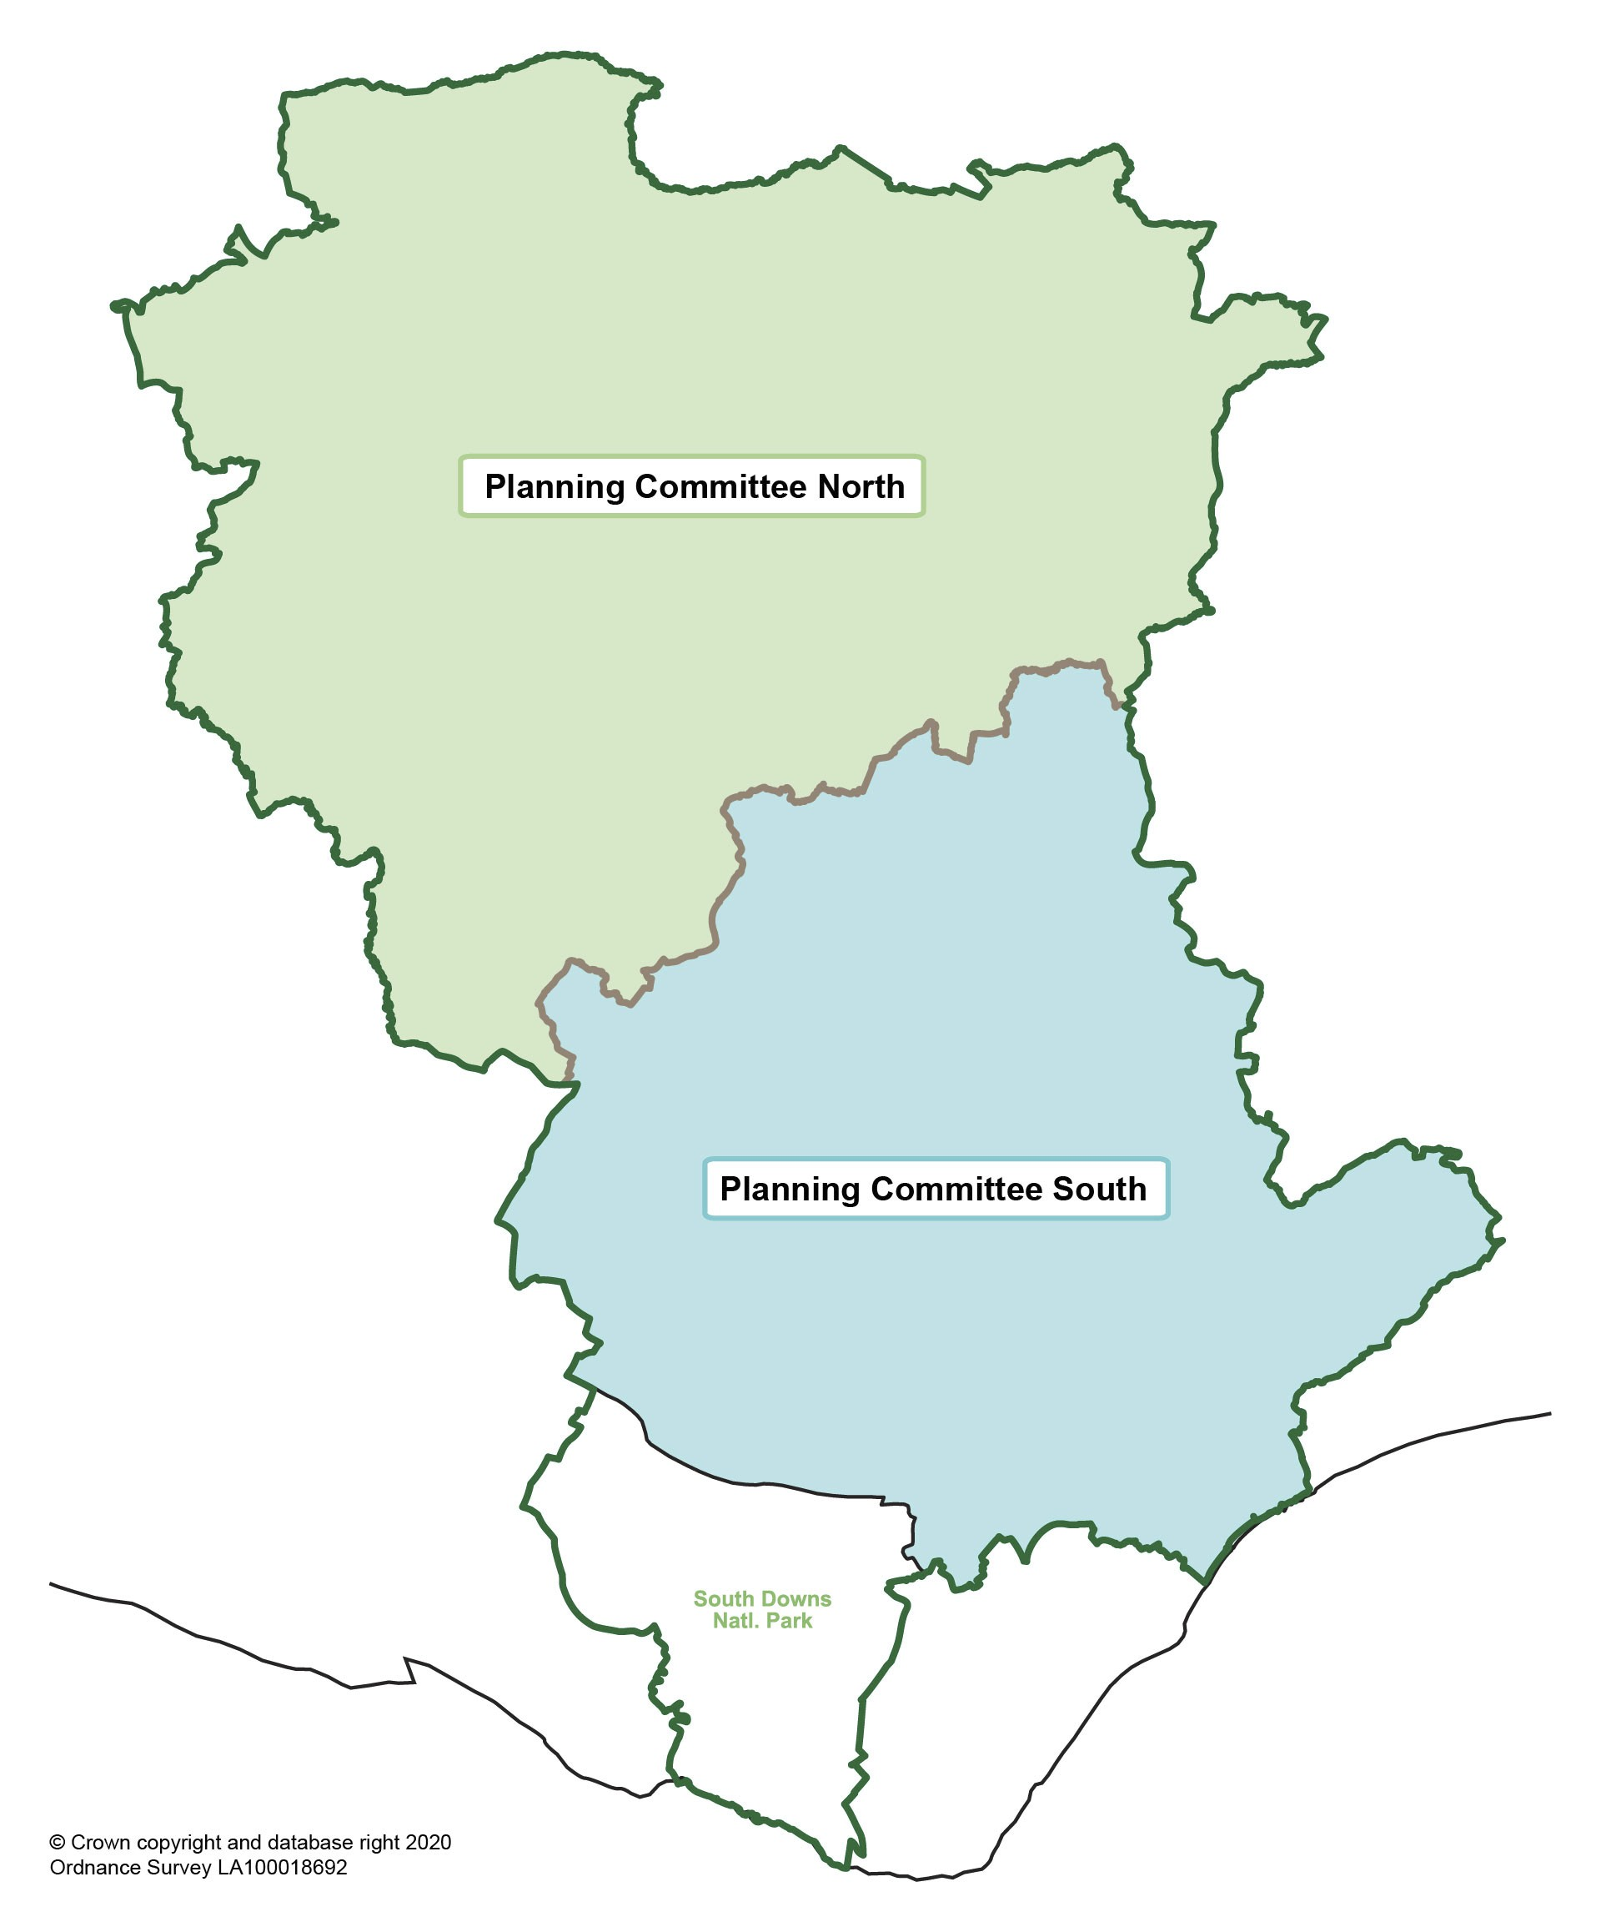

Wealden Local Plan
Draft Statement of Community Involvement May 2020

Figure 5: Planning Committee’s North and South

8.21 When applications are reported to a Planning Committee, the Council operates a
public speaking scheme where applicants, supporters and objectors can address the
Committee for a specified time, details of which can be found on the Council’s website
here: Council-and-committee-meetings
30
8 Development Management and community involvement

Wealden Local Plan
Draft Statement of Community Involvement May 2020

8.22 Where people have commented on the application, the Council will write to inform
them when and where the application will be considered and the arrangements for public
speaking. A request to address the Planning Committee is required prior to the meeting.
8.23 When a formal decision is made on an application, either through delegated powers or by a Planning Committee, a decision notice will be published on the Council’s website and anyone who has commented on the application will be notified of the decision. Notification of any subsequent appeal will also be provided to any interested party who commented on the application.
Planning Appeals
8.24 It is possible for an applicant or a developer to appeal a planning decision if the
application has been refused or if an application has not been determined within the
statutory timeframes. It is also possible to appeal against the grant of planning permission
that is subject to conditions that restrict or control the manner in which planning permission
is to be implemented.
8.25 Third parties and members of the public cannot appeal against the council's
decision on a planning application. Any challenge to a planning decision from third parties
or members of the public can only be in the High Court by Judicial Review. Further
information can be found here: Planning-court
8.26 Planning appeals are determined by the Secretary of State, who will appoint a Planning Inspector to consider and hear the appeal. The appeal process is undertaken by one of three methods:
Written representations; Public hearing; or
Public inquiry.
8.27 When Wealden District Council is notified of an appeal by the Planning Inspectorate,
often referred to as ‘PINS’, we will contact all those originally consulted on the application
letting them know the appeal has been made. The council will send copies of all letters
originally received about the application to the Planning Inspector. Advice will be given
as to how to make further representations to the Planning Inspector who will determine
the appeal. Interested parties are advised of how they can be involved in the appeal
process.
8.28 If an appeal is to be considered at an informal hearing or public inquiry, the Council will also notify interested parties of the venue and time of the hearing in line with the Planning Inspectorate’s requirements.
8.29 The Planning Inspector will make a decision to either allow or dismiss the appeal
or alternatively a decision will be deferred to the Secretary of State for a final decision.
Once the decision is made a decision notice will be sent to the appellant, the Council and
any interested person who has requested a copy of the decision. The decision will also

be available on the Council's and planning Inspectorate website at: CaseSearch
31

8 Development Management and community involvement

Wealden Local Plan
Draft Statement of Community Involvement May 2020

8.30 The council lists all planning appeals lodged and all planning appeals decided in the past six months on the Councils website.
How we use your data
8.31 Planning is an open and public activity. Any representations or comments made
by members of the community, stakeholders and other relevant parties during the
preparation of planning documents or in relation to a planning application may and can
be made public. However, we will redact personal information from any comments
published.
8.32 If you would like to know how the Council uses and manages personal data in
relation to planning policy documents or in relation to planning applications then you can
access the Council’s privacy notice via Data-protection/privacy-policy

32
8 Development Management and community involvement

Wealden Local Plan
Draft Statement of Community Involvement May 2020

9 How we use your data
9.1 Planning is an open and public activity. Any representations or comments made by
members of the community, stakeholders and other relevant parties during the preparation
of planning documents or in relation to a planning application may and can be made
public. However, we will redact personal information from any comments published.
9.2 If you would like to know how the Council uses and manages personal data in
relation to planning policy documents or in relation to planning applications then you can
access the Council’s privacy notice via Data-protection/privacy-policy

33
9 How we use your data

Wealden Local Plan
Draft Statement of Community Involvement May 2020

34
9 How we use your data

Wealden Local Plan
Draft Statement of Community Involvement May 2020

10 Glossary
Disclaimer
This glossary is neither a statement of law nor an interpretation of the law, and its status is only an introductory guide to planning issues and should not be used as a source for statutory definitions.
Authority Monitoring Report (AMR): The AMR is the main mechanism for assessing
the performance and effects of the policies contained in the current Development Plan
and the timescales set out for the emerging Local Plan though the Local Development
Scheme (LDS).
Community Infrastructure Levy (CIL): A levy allowing local authorities to raise funds from owners or developers of land undertaking new building projects in their area.
Community Right to Build Order: An Order made by the local planning authority (under the Town and Country Planning Act 1990) that grants planning permission for a site-specific development proposal or classes of development.
Development Plan: Is defined in section 38 of the Planning and Compulsory Purchase
Act 2004, and includes adopted local plans and neighbourhood plans. Neighbourhood
plans that have been approved at referendum are also part of the development plan,
unless the local planning authority decides that the neighbourhood plan should not be
made.
Habitats Site: Any site which would be included within the definition at regulation 8 of
the Conservation of Habitats and Species Regulations 2017 for the purpose of those
regulations, including any Special Areas of Conservation, Sites of Community Importance,
Special Areas of Conservation, Special Protection Areas and any relevant Marine Sites.
Local Development Scheme: A project management plan that describes the Council’s
programme for producing its Local Development Plan Documents, such as the Local
Plan.
Local Plan: A plan for the future development of a local area, drawn up by the local
planning authority in consultation with the community. In law this is described as the
development plan documents adopted under the Planning and Compulsory Purchase Act
2004. A local plan can consist of either strategic or non-strategic policies, or a combination
of the two.
Neighbourhood Development Order: An Order made by a local planning authority (under the Town and Country Planning Act 1990) through which parish councils and neighbourhood forums can grant planning permission for a specific development proposal or classes of development.

35
10 Glossary

Wealden Local Plan
Draft Statement of Community Involvement May 2020

Neighbourhood Plans: A plan prepared by a parish council or neighbourhood forum for a designated neighbourhood area. In law this is described as a neighbourhood development plan in the Planning and Compulsory Purchase Act 2004.
Permission in Principle: A form of planning consent which establishes that a site is suitable for a specified amount of housing-led development in principle. Following a grant of permission in principle, the site must receive a grant of technical details consent before development can proceed.
South Downs National Park Authority (SDNPA): The South Downs National Park
Authority is the statutory planning authority for the National Park area and was formed in
2011.
Strategic Environmental Assessment (SEA): A procedure (set out in the Environmental Assessment of Plans and Programmes Regulations 2004) which requires the formal environmental assessment of certain plans and programmes which are likely to have significant effects on the environment.
Statement of Community Involvement: A public statement of the Council’s intentions
for involving the community in the production of its Local Development Plan Documents
(such as Local Plans), and its ongoing development management decisions (i.e. planning
applications).
Supplementary Planning Document: Documents which add further detail to the policies in the development plan. They can be used to provide further guidance for development on specific sites, or on particular issues, such as design. Supplementary planning documents are capable of being a material consideration in planning decisions but are not part of the development plan.
Sustainability Appraisal (SA): An evaluation of the social, economic and environmental
impacts of policies and strategies in a Local Development Plan Document to ensure the
policies and strategies are in accordance with sustainable development objectives.

36
10 Glossary

Wealden Local Plan
Draft Statement of Community Involvement May 2020

Appendix A
Appendix A - Duty to Cooperate partners and prescribed bodies

Local Authority Duty to Cooperate Partners Other prescribed bodies

Eastbourne Borough Council; Rother District Council;
Tunbridge Wells Borough Council; Tandridge District Council;
Mid Sussex District Council; Sevenoaks District Council; Lewes District Council;
Hastings Borough Council;
Brighton and Hove City Council;
South Downs National Park Authority; East Sussex County Council;
West Sussex County Council; and
Kent County Council.
the Environment Agency;
the Historic Buildings and Monuments Commission for England (known as Historic England);
Natural England;
the Civil Aviation Authority;
the Homes and Communities Agency; each clinical commissioning group
established under section 14D of the National Health Service Act 2006; the National Health Service
Commissioning Board;
the Office of Rail Regulation; the Highways Authority; the Highways Agency;
the Marine Management Organisation;
and
Local Enterprise Partnerships.

37
Appendix A

Wealden Local Plan
Draft Statement of Community Involvement May 2020

38
Appendix A

Wealden Local Plan
Draft Statement of Community Involvement May 2020

Appendix B
Appendix B - Specific and general consultation bodies

Specific Consultation Bodies General Consultation Bodies and other
interested groups

Adjoining Local Planning Authorities and Councils as set out in Appendix A East Sussex County Council;
Parish and Town Councils (within and adjoining the plan area);
The Police and Crime Commissioners; The Coal Authority;
The Environment Agency;
English Heritage (Historic Buildings and Monuments Commission for England);
Marine Management Organisation; Natural England;
Network Rail Infrastructure Limited; The Highways Agency;
Relevant telecommunications companies;
Relevant Clinical Commissioning Group(s);
NHS Commissioning Board;
Relevant electricity and gas companies / operators;
Relevant water and sewerage companies; and
The Homes and Communities Agency.
Nature Conservation / countryside bodies;
Environmental groups;
Infrastructure and service providers; Learning agencies;
Recreation bodies;
Local Nature Partnership; Disabled groups;
Ethnic/racial/national groups; Local businesses;
Religious groups and churches; Voluntary bodies; and
Other miscellaneous bodies.

39
Appendix B

Wealden Local Plan
Draft Statement of Community Involvement May 2020

40
Appendix B

Wealden Local Plan
Draft Statement of Community Involvement May 2020

Appendix C
Appendix C - How we consult in relation to specific types of applications.

Type of Development | Site  notice | Newspaper  advertisement | Website | MyAlerts  (opt-in  service)
Applications for major development as  defined in Article 2 of the Development  Management Procedure Order (which  are not covered in any other entry) | Y | Y | Y | Y
Applications subject to Environmental  Impact Assessment which are  accompanied by an environmental  statement | Y | Y | Y | Y
Applications which do not accord with  the development plan in force in the area | Y | Y | Y | Y
Applications which would affect a right  of way to which Part 3 of the Wildlife and  Countryside Act 1981 applies | Y | Y | Y | Y
Applications for planning permission not  covered in the entries above eg  non-major development | Y | N | Y | Y
Applications for listed building consent  where works to the exterior of the  building are proposed | Y | Y | Y | Y
Applications to vary or discharge  conditions attached to a listed building  consent or involving exterior works to a  listed building. | Y | Y | Y | Y
Applications for development which  would affect the setting of a listed  building, or affect the character or  appearance of a conservation area. | Y | Y | Y | Y

41
Appendix C

Wealden Local Plan
Draft Statement of Community Involvement May 2020

42
Appendix C

Published by
Wealden District Council
Council Offices
Vicarage Lane
Hailsham
East Sussex BN27 2AX
Tel: 01323 443322 Fax: 01323 443333
e-mail: planningpolicy@wealden.gov.uk
Website: www.wealden.gov.uk

